 | AgroMet Advisory Bulletin (AAB)  Jointly released by  Regional Meteorology Centre, Chennai – India Meteorology Department,  Reddiarchathram Seed Growers Association &  M. S. Swaminathan Research Foundation, Kannivadi  Phone no.: 044 - 22541229 E mail: amfu.kanniwadi@gmail.com Fax: 044 – 22541319 |  |  |  |  |  | 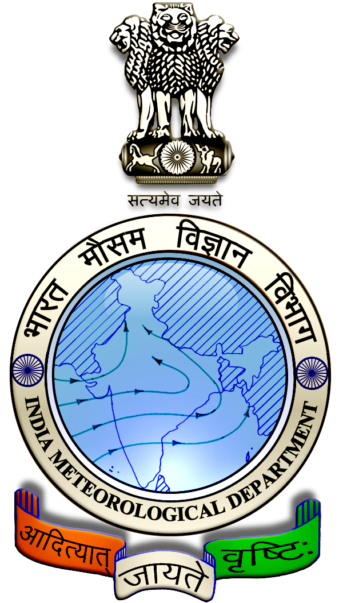
 | District : | Dindigul | Forecast Period : | 21/08/2024 | to | 25/08/2024
 | Bulletin No: | MSSRF/ DGL /067/ 2024 | Release Date : | 20/08/2024

Significant past weather | From |  | 16/08/2024 | to | 19/08/2024
Parameters |  | Past Weather
Rainfall (mm) |  | 33.1
Maximum Temperature (ºC) |  | 35-36
Minimum Temperature (ºC) |  | 25-27
Sky Condition (Octas) |  | 4-8
Relative Humidity (%) |  | 62-89
Wind Speed (kmph) |  | 4-9

Ensemble Weather Forecast until | 08:30Hrs of |  | 25-08-2024
Parameters | 21-08-2024 | 22-08-2024 |  | 23-08-2024 | 24-08-2024 | 25-08-2024
Parameters | Wednesday | Thursday |  | Friday | Saturday | Sunday
Rainfall (mm) | 25 | 26 |  | 2 | 4 | 3
Maximum Temperature (°C) | 35 | 34 |  | 34 | 33 | 33
Minimum Temperature (°C) | 25 | 24 |  | 23 | 23 | 23
Sky Condition (Octa) | 8 | 8 |  | 8 | 6 | 6
Max. Relative Humidity (%) | 80 | 80 |  | 70 | 70 | 70
Min. Relative Humidity (%) | 60 | 40 |  | 40 | 50 | 40
Wind Speed (Kmph) | 6 | 8 |  | 6 | 10 | 12
Wind Direction | SW | SW |  | SW | SW | W

SMS Advisory | Chances of Moderate rain on 21, 22 Aug & light rain during 23, 24, 25 Aug. Maximum temperature would be in the range of 33℃ to 35℃ and the minimum temperature would be between 23℃ - 25℃. Cloudy sky will appear for the next five days. Wind is expected with the speed of 6 – 12 Kmph from, Southwest & West directions.

General Advisory:
Extended range Forecast for next week (23rd to 29th August 2024):

Rainfall:
As per extended range predictions, there is possibility of above normal rainfall likely over the district during 23rd to 29th August 2024.

Maximum Temperature:
Maximum temperatures are likely to be near normal and are likely to be in the range 26°C to 32°C over the plains of the district during next week. 23rd to 29th August 2024.

Minimum Temperature:
Minimum temperatures are likely to be near normal and are likely to be in the range 18°C to 24°C over the district during next week 23rd to 29th August 2024.

Heavy rain is likely to occur at isolated places over the district on 21 & 22 August 2024. Farmers are advised to act swiftly to repair the water channels, farm ponds and other water bodies to harvest the rain water. During these days farmers are advised to avoid irrigation, intercultural operations and application of plant protection measures to the standing crops, provide adequate drainage facilities in the fields to avoid water stagnation due to heavy rainfall, do not allow the animals to grazing outside, standing near the trees or electric poles & provide safe shelter.

Livestock:
Light to Moderate rain with thunderstorm & lightning is likely to occur at isolated places over the district on 21 & 22 August 2024. Farmers are advised to take precautionary measures while grazing/ herding the sheep, goat, cow on agriculture land for manuring purpose. Do not allow the animals to graze outside, standing near the trees or electric poles. Provide safe shelter for your livestock.

Weather Based Agro-Advisories: (Bhendi, Jasmine & Animal Husbandry)
Bhendi:
At this prevailing weather condition, a foliar spray of nutrition is essential to increase the yield in Bhendi crop.

After 30 days of sowing, spray one per cent urea solution three times at an interval of 10 days.

By dissolving 17 grams of muriate of potash in one litre of water and spraying on the 30th, 45th and 60th day of sowing, the yield can be increased.

For hybrids, spray 5%(5g per litre) water soluble 19-19-19 fertilizer 3 times at an interval of 10 days from the 30th day of planting.

Jasmine:
The incidence of sucking pests is noticed in floricultural crops such as Rose, Jasmine and Tuberose.

These pests affect at all the stages of the crop.

To control the sucking pests, tie Yellow sticky trap at 15-20 traps per acre.

Using chemical method, spraying of Prophenophos @ 2 ml per litre of water is recommended.

Animal Husbandry:
To protect the livestock from thunderstorms and lightning Farmers are requested to avoid grazing the animals during rains, particularly grazing sheep and goat in the flock which are more prone to lightning shock.

Farmers should avoid tethering animals near barbed wire fencing posts and trees. Trees near the animal sheds should be pruned to avoid accidental falls over during heavy wind.

Further trees like rain trees and vathanarayanan are more prone to uprooting. More chance of lightning near the hilly area and undulated landscapes than in plains.

Fence with wooden poles and metal wires, it is advisable to check the condition of the buried parts at most once in 5 years and do the necessary replacement before the thunderstorm season begins.

