 | AgroMet Advisory Bulletin (AAB)  Jointly released by  Regional Meteorology Centre, Chennai – India Meteorology Department,  Reddiarchathram Seed Growers Association &  M. S. Swaminathan Research Foundation, Kannivadi  Phone no.: 044 - 22541229 E mail: amfu.kanniwadi@gmail.com Fax: 044 – 22541319 |  |  |  |  |  | 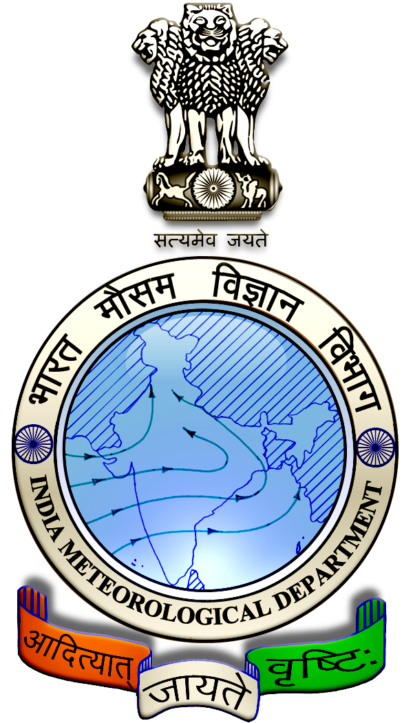
 | District : | Madurai | Forecast Period : | 21/08/2024 | to | 25/08/2024
 | Bulletine No : | MSSRF/ MDU / 067/ 2024 | Release Date : | 20/08/2024

Significant past weather | From |  | 16/08/2024 | to | 19/08/2024
Parameters |  | Past Weather
Rainfall (mm) |  | 24.2
Maximum Temperature (ºC) |  | 35-36
Minimum Temperature (ºC) |  | 25-27
Sky Condition (Octas) |  | 4-8
Relative Humidity (%) |  | 62-89
Wind Speed (kmph) |  | 4-9

Ensemble Weather Forecast until | 08:30Hrs of | 25-08-2024
Parameters | 21-08-2024 | 22-08-2024 | 23-08-2024 | 24-08-2024 | 25-08-2024
Parameters | Wednesday | Thursday | Friday | Saturday | Sunday
Rainfall (mm) | 24 | 10 | 3 | 2 | 3
Maximum Temperature (°C) | 35 | 34 | 34 | 33 | 33
Minimum Temperature (°C) | 25 | 24 | 23 | 23 | 23
Sky Condition (Octas) | 8 | 8 | 8 | 6 | 6
Max. Relative Humidity (%) | 80 | 80 | 70 | 70 | 70
Min. Relative Humidity (%) | 60 | 40 | 40 | 50 | 40
Wind Speed (Kmph) | 12 | 14 | 10 | 14 | 14
Wind Direction | SW | SW | SW | SW | SW

SMS Advisory | Chances of Moderate rain on 21, 22 Aug & light rain during 23, 24, 25 Aug. Maximum temperature would be in the range of 33℃ to 35℃ and the minimum temperature would be between 23℃ - 25℃. Cloudy sky will appear for the next five days. Wind is expected with the speed of 10 – 14 Kmph from, Southwest direction.

General Advisory:
Extended range Forecast for next week (23rd to 29th August 2024):

Rainfall:
As per extended range predictions, there is possibility of above normal rainfall likely over the district during 23rd to 29th August 2024.

Maximum Temperature:
Maximum temperatures are likely to be near normal and are likely to be in the range 26°C to 32°C over the plains of the district during next week. 23rd to 29th August 2024.

Minimum Temperature:
Minimum temperatures are likely to be near normal and are likely to be in the range 18°C to 24°C over the district during next week 23rd to 29th August 2024.

Heavy rain is likely to occur at isolated places over the district on 21 August 2024. 8Farmers are advised to act swiftly to repair the water channels, farm ponds and other water bodies to harvest the rain water. During these days farmers are advised to avoid irrigation, intercultural operations and application of plant protection measures to the standing crops, provide adequate drainage facilities in the fields to avoid water stagnation due to heavy rainfall, do not allow the animals to grazing outside, standing near the trees or electric poles & provide safe shelter.

Livestock:
Light to Moderate rain with thunderstorm & lightning is likely to occur at isolated places over the district on 21 & 22 August 2024. Farmers are advised to take precautionary measures while grazing/ herding the sheep, goat, cow on agriculture land for manuring purpose. Do not allow the animals to graze outside, standing near the trees or electric poles. Provide safe shelter for your livestock.

Weather Based Agro-Advisories: (Banana, Paddy & Animal Husbandry)
Banana:
Farmers who have planted banana crop should apply 20gm each of Azospirillum and Phosphobacteria per plant at the growing stage, once at one month after planting and again after 5 months after planting.

Paddy:
Kind attention to Paddy cultivators, paddy crops are prone to the attack of sap sucking insects due to high humidity in the air. Spray Azadirachtin @ 2ml/litre of water with sticking paste, to control thrips and sap sucking insects.

Animal Husbandry:
To protect the livestock from thunderstorms and lightning Farmers are requested to avoid grazing the animals during rains, particularly grazing sheep and goat in the flock which are more prone to lightning shock.

Farmers should avoid tethering animals near barbed wire fencing posts and trees. Trees near the animal sheds should be pruned to avoid accidental falls over during heavy wind.

Further trees like rain trees and vathanarayanan are more prone to uprooting. More chance of lightning near the hilly area and undulated landscapes than in plains.

Fence with wooden poles and metal wires, it is advisable to check the condition of the buried parts at most once in 5 years and do the necessary replacement before the thunderstorm season begins.

