 | AgroMet Advisory Bulletin (AAB)  Jointly released by  Regional Meteorology Centre, Chennai – India Meteorology Department,  Reddiarchathram Seed Growers Association &  M. S. Swaminathan Research Foundation, Kannivadi  Phone no.: 044 - 22541229 E mail: amfu.kanniwadi@gmail.com Fax: 044 – 22541319 |  |  |  |  |  | 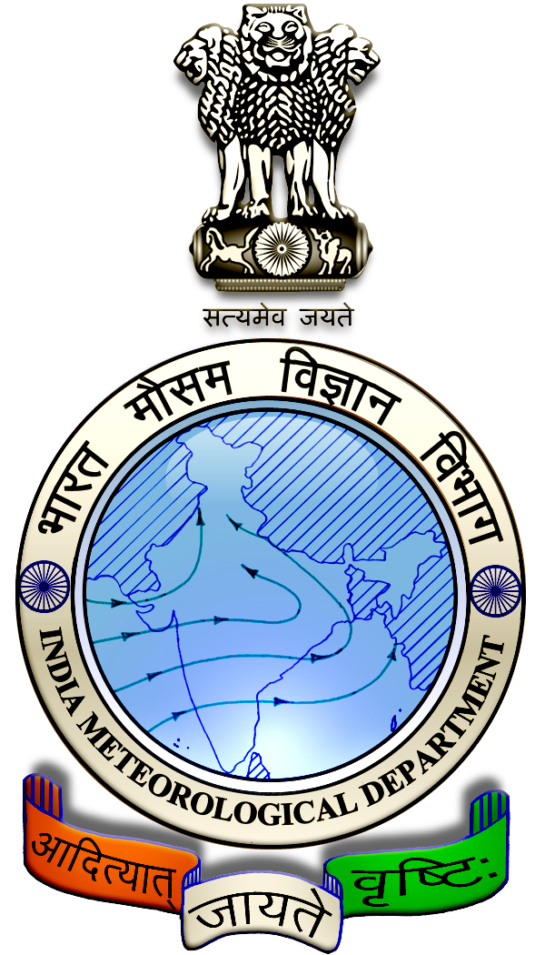
 | District : | Ramanathapuram | Forecast Period : | 21/08/2024 | to | 25/08/2024
 | Bulletin No: | MSSRF/ RMD /067/ 2024 | Release Date : | 20/08/2024

Significant past weather | From |  | 16/08/2024 | to | 19/08/2024
Parameters |  | Past Weather
Rainfall (mm) |  | 10.0
Maximum Temperature (ºC) |  | 33-35
Minimum Temperature (ºC) |  | 25-27
Sky Condition (Octas) |  | 4-5
Relative Humidity (%) |  | 58-80
Wind Speed (kmph) |  | 0-4

Ensemble Weather Forecast until | 08:30Hrs of |  | 25-08-2024
Parameters | 21-08-2024 | 22-08-2024 |  | 23-08-2024 | 24-08-2024 | 25-08-2024
Parameters | Wednesday | Thursday |  | Friday | Saturday | Sunday
Rainfall (mm) | 0 | 5 |  | 0 | 0 | 0
Maximum Temperature (°C) | 34 | 35 |  | 34 | 34 | 35
Minimum Temperature (°C) | 25 | 24 |  | 24 | 23 | 24
Sky Condition (Octa) | 6 | 8 |  | 5 | 5 | 4
Max. Relative Humidity (%) | 70 | 70 |  | 70 | 70 | 60
Min. Relative Humidity (%) | 60 | 50 |  | 50 | 50 | 40
Wind Speed (Kmph) | 30 | 30 |  | 30 | 30 | 26
Wind Direction | SW | SW |  | SW | SW | SW

SMS Advisory | Chances of light rain on 22 Aug. Maximum temperature would be in the range of 34℃ to 35℃ and the minimum temperature would be between 23℃ - 25℃. Generally cloudy sky will appear for the next five days. Wind is expected with the speed of 26 – 30 Kmph from, Southwest direction.

General Advisory:
Extended range Forecast for next week (23rd to 29th August 2024):

Rainfall:
As per extended range predictions, there is possibility of above normal rainfall likely over the district during 23rd to 29th August 2024.

Maximum Temperature:
Maximum temperatures are likely to be near normal and are likely to be in the range 32°C to 36°C over the plains of the district during next week. 23rd to 29th August 2024.

Minimum Temperature:
Minimum temperatures are likely to be near normal and are likely to be in the range 24°C to 26°C over the district during next week 23rd to 29th August 2024.

Wind with the speed of 26 to 30 kmph is expected for the next five days. Hence farmers are advised to provide propping in sugarcane and to provide adequate support for crops like Banana, Papaya, Guava and Moringa, to prevent from lodging. For Gourds check the structures /pandhals for damages in the strings and poles and provide adequate support. Postpone the spraying activity.

Livestock:
Light to Moderate rain with thunderstorm & lightning is likely to occur at isolated places over the district on 21 & 22 August 2024. Farmers are advised to take precautionary measures while grazing/ herding the sheep, goat, cow on agriculture land for manuring purpose. Do not allow the animals to graze outside, standing near the trees or electric poles. Provide safe shelter for your livestock.

Weather Based Agro-Advisories: (Tomato, Black gram & Animal Husbandry)
Tomato:
There are chances for the spread of soil-borne diseases in the tomato crop planted under rain fed conditions.

To control such diseases, apply biocontrol agents like Trichoderma viride and Pseudomonas fluorescence each at 5 kg per acre well mixed with adequate manure.

Black gram:
Spraying of the micronutrient is important for the Blackgram crop. Foliar spray of NAA 40mg/litre and Salicylic acid 100 mg/litre once at pre-flowering and another at 15 days later.
For rice fallow crops, foliar spray of DAP 20gm/litre once at flowering and another at 15 days later.
For irrigated and rain-fed crops, foliar spray of DAP 20gm/litre or Urea 20 gm/litre once at flowering and another at 15 days later.
Animal Husbandry:
To protect the livestock from thunderstorms and lightning Farmers are requested to avoid grazing the animals during rains, particularly grazing sheep and goat in the flock which are more prone to lightning shock.

Farmers should avoid tethering animals near barbed wire fencing posts and trees. Trees near the animal sheds should be pruned to avoid accidental falls over during heavy wind.

Further trees like rain trees and vathanarayanan are more prone to uprooting. More chance of lightning near the hilly area and undulated landscapes than in plains.

Fence with wooden poles and metal wires, it is advisable to check the condition of the buried parts at most once in 5 years and do the necessary replacement before the thunderstorm season begins.

