 | AgroMet Advisory Bulletin (AAB)  Jointly released by  Regional Meteorology Centre, Chennai – India Meteorology Department,  Reddiarchathram Seed Growers Association &  M. S. Swaminathan Research Foundation, Kannivadi  Phone no.: 044 - 22541229 E mail: amfu.kanniwadi@gmail.com Fax: 044 – 22541319 |  |  |  |  |  | 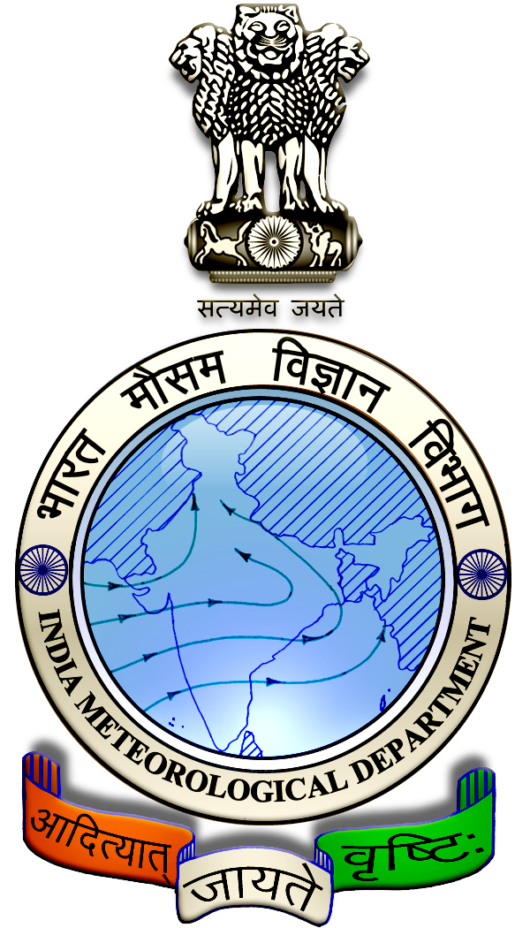
 | District : | Dindigul | Forecast Period : | 17/01/2024 | to | 21/01/2024
 | Bulletin No: | MSSRF/ DGL /005/ 2024 | Release Date : | 16/01/2024

Significant past weather | From |  | 12/01/2024 | to | 15/01/2024
Parameters |  | Past Weather
Rainfall (mm) |  | 0.0
Maximum Temperature (ºC) |  | 31-32
Minimum Temperature (ºC) |  | 21-23
Sky Condition (Octas) |  | 3-5
Relative Humidity (%) |  | 50-88
Wind Speed (kmph) |  | 6-9

Ensemble Weather Forecast until | 08:30Hrs of |  | 21-01-2024
Parameters | 17-01-2024 | 18-01-2024 |  | 19-01-2024 | 20-01-2024 | 21-01-2024
Parameters | Wednesday | Thursday |  | Friday | Saturday | Sunday
Rainfall (mm) | 0 | 0 |  | 0 | 0 | 0
Maximum Temperature (°C) | 31 | 30 |  | 30 | 30 | 29
Minimum Temperature (°C) | 21 | 21 |  | 20 | 20 | 20
Sky Condition (Octa) | 3 | 0 |  | 0 | 1 | 1
Max. Relative Humidity (%) | 80 | 80 |  | 90 | 90 | 80
Min. Relative Humidity (%) | 40 | 40 |  | 50 | 40 | 40
Wind Speed (Kmph) | 6 | 6 |  | 6 | 8 | 6
Wind Direction | E | E |  | E | NE | NE

SMS Advisory | For the next five days, Maximum temperature would be in the range of 29℃ to 31℃ and the minimum temperature would be between 20℃-21℃. Mainly clear sky will appear for the next five days. Wind expected with the speed of 6-8 Kmph from, East & Northeast directions.

General Advisory:
Extended range Forecast for next week (19th – 25th Jan 2024):

Rainfall:
As per extended range predictions, there is possibility of generally dry condition likely over the district during 19th to 25th January 2024.

Maximum Temperature:
Maximum temperatures is likely to be to near normal to slightly below normal and are likely to be in the range 26°C to 32°C over the plains of the district during next week. 19th to 25th January 2024.

Minimum Temperature:
Minimum temperatures are likely to be near normal to slightly above normal and are likely to be in the range 16°C to 20°C over the district during next week 19th to 25th January 2024.
Mostly dry weather is expected for the next 5 days, during these days, farmers can plan for crop protection activities.

Weather Based Agro-Advisories: (Paddy, Brinjal & Animal Husbandry).
Paddy:
The incidence of Paddy Leaf folder expected in Paddy crop, the symptoms are leaves folding longitudinally and larvae remaining inside. Larvae scrap the green tissue of the leaves and become white and dry. During a severe infestation, the whole field exhibits a scorched appearance.

To control this, tie Trichogramma egg parasitoid cards @ 5cc per acre, thrice at the 37th, 44th, and 51st days after transplanting.

Avoid excessive application of urea.

Install Light trap at 1No. per acre.

Spray NSKE @ 5ml per litre of water or spray Chlorpyrifos 20 EC @ 5ml per litre of water.

Brinjal:
The occurrence of sucking pests like Aphids & whiteflies may be noticed in the Brinjal crop.

To control, mix Neem Oil @ 50ml + Pseudomonas @ 50gm + Sticky agent @ 10ml with 10 litres of water. Spray 2 times at 10 days intervals.

Tie Yellow sticky traps @ 10 per acre and Blue sticky traps @ 5 per acre.

Animal Husbandry:
To control the ecto-parasites in sheep & goats,Goat rearing farmers are advised to apply Butox solution (2ml Butox in 1 litre water) externally.

