 | AgroMet Advisory Bulletin (AAB)  Jointly released by  Regional Meteorology Centre, Chennai – India Meteorology Department,  Reddiarchathram Seed Growers Association &  M. S. Swaminathan Research Foundation, Kannivadi  Phone no.: 044 - 22541229 E mail: amfu.kanniwadi@gmail.com Fax: 044 – 22541319 |  |  |  |  |  | 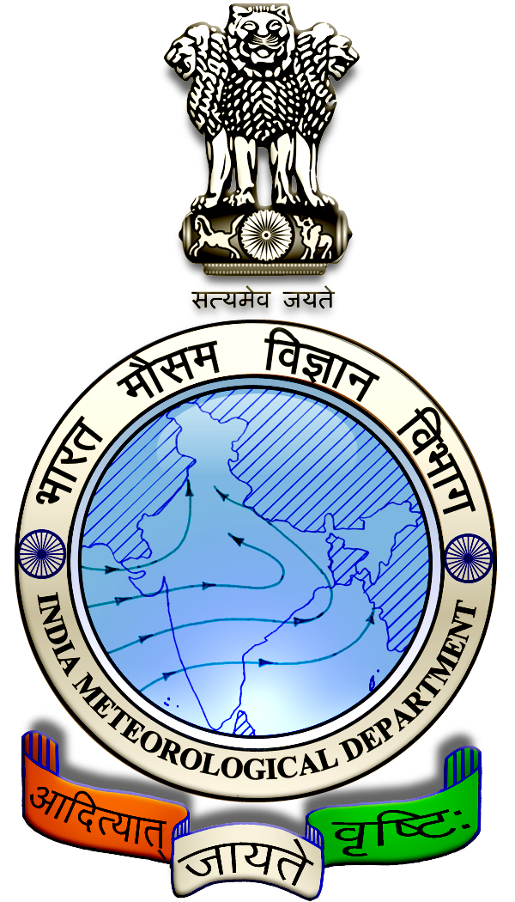
 | District : | Sivagangai | Forecast Period : | 01/05/2024 | to | 05/05/2024
 | Bulletine No : | MSSRF/SVG / 035/ 2024 | Release Date : | 30/04/2024

Significant past weather | From |  | 26/04/2024 | to | 29/04/2024
Parameters |  | Past Weather
Rainfall (mm) |  | 0.0
Maximum Temperature (ºC) |  | 39-40
Minimum Temperature (ºC) |  | 26-28
Sky Condition (Octas) |  | 3-5
Relative Humidity (%) |  | 35-72
Wind Speed (kmph) |  | 9-14

Ensemble Weather Forecast until | 08:30Hrs of | 05-05-2024
Parameters | 01-05-2024 | 02-05-2024 | 03-05-2024 | 04-05-2024 | 05-05-2024
Parameters | Wednesday | Thursday | Friday | Saturday | Sunday
Rainfall (mm) | 0 | 0 | 0 | 0 | 0
Maximum Temperature (°C) | 40 | 41 | 41 | 41 | 40
Minimum Temperature (°C) | 28 | 28 | 27 | 27 | 27
Sky Condition (Octas) | 5 | 4 | 2 | 6 | 3
Max. Relative Humidity (%) | 70 | 70 | 70 | 70 | 70
Min. Relative Humidity (%) | 20 | 20 | 30 | 30 | 20
Wind Speed (Kmph) | 16 | 18 | 22 | 20 | 20
Wind Direction | S | S | S | S | S

SMS Advisory | Dry weather will prevail for the next 5 days, Maximum temperature would be in the range of 40℃ to 41℃ and the minimum temperature would be between 27℃ - 28℃. Partly cloudy sky will appear for the next five days. Wind is expected with the speed of 16-22 Kmph from, South direction.

General Advisory:
Owing to high maximum temperature and moderate wind, more moisture loss is expected and hence, more irrigation should be given to the standing crops.

Livestock:
Artificial insemination of goats and cows should be done within 9 am or after 4pm due to the high heat of the day.

For livestock, the heat stress can be managed by spraying/ sprinkling water directly on the body of animals for a period of 1 to 5 minutes at an interval of 30-60 minutes. Cover the sides of the cow shed with wet gunny bags. Ensure the increased mineral supplementation to the animals during hot weather to meet the increased demand for minerals. The potassium-rich mineral mixture should be preferred for your cattle.

Agriculture:
Due to hot and humid conditions, discomfort weather is likely at isolated pockets over the district during next five days (01.05.2024 to 05.05.2024). Hence farmers are advised to plan their field activities during morning and evening hours and avoid working in the field during 12 noon to 4 Pm. Stay safe and take care. Drink adequate water.

Wind with the speed of 16 to 22 kmphis expected for the next five days. Hence farmers are advised to provide propping in sugarcane and to provide adequate support for crops like Banana, Papaya, Guava and Moringa, to prevent from lodging. For Gourds check the structures /pandhals for damages in the strings and poles and provide adequate support. Postpone the spraying activity.

Weather Based Agro – Advisories: (Important Crops: Drumstick, Guava & Animal Husbandry)

Drumstick:
Drumstick cultivating farmers are advised to follow the fertilizer recommendation for the annual Moringa crop.

A fertilizer dose of 45:16:30 grams of NPK per pit may be applied 3 months after sowing.

Apply 45g of Nitrogen per pit after 6 months when the crop is in the bearing stage.

Guava:
The incidence of Fruit flies is expected in Guava. The symptoms of damage appear on fruits. The fruit fly adults and maggots attack the semi–ripened fruits, ovipositor punctures are found on fruits, and maggots destroy the pulp and a bad smell comes out of it.

To control this, set up pheromone traps. Fill a 5-litre bucket with 3 litres of water + 2 dry fish + 50gm Jaggery + 2 well-rotten Bananas + 1kg castor cake + 2 pieces of Pineapple and fix it as 12 Nos per Acre.

Animal Husbandry:
Livestock can be treated with summer feed mixed with 40 g of mineral salt, 50 g of dry yeast or 150 g of sodium bicarbonate.

This reduces the heat dissipation that appears in dairy cows and increases the amount of milk and fat and non-fat solids in the milk.

